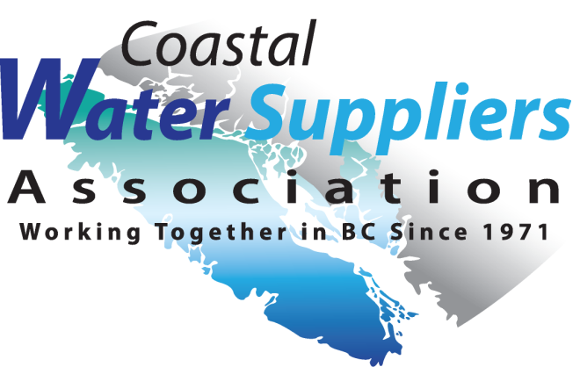
CWSA
PO Box 415
Shawnigan Lake, BC V0R 2W0

Annual Delegate Membership Application 2022

Membership is open to Improvement Districts, Municipalities, Regional Districts & Private Water Purveyors.
Water System: __________________________________________________

Administrator, Title/Name: __________________________________________________

Mailing Address: __________________________________________________
__________________________________________________
Phone: _______________________________________
Email: _______________________________________
Website: _______________________________________
Water source: surface water or ground water
Service Connections: Membership Rates:
1-50 $29
51-100 $46
101-300 $115
301-500 $173
501+ $230

Total Amount Enclosed $ ________________

If paying by cheque, please include the Annual Delegate Membership Application form with your payment to ensure
CWSA has your updated contact information.

Coastal Water Suppliers Association (CWSA)
PO Box 415
Shawnigan Lake, BC. V0R 2W0
or
You may register and renew membership online at www.cwsa.net by Paypal.
For questions, please give us a call.

We gratefully acknowledge the financial support of the Province of British Columbia, BC One Call, and
MPE Engineering Ltd.

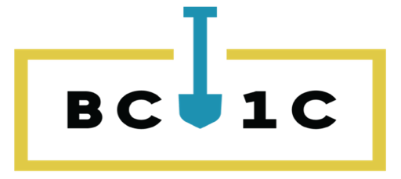

coastalwatersuppliers@gmail.com (250) 731-5557 phone www.cwsa.net

