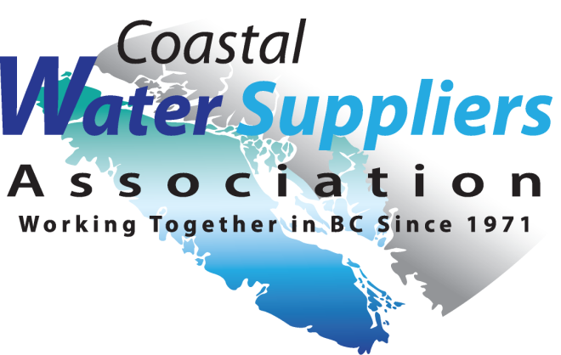
CWSA
PO Box 415
Shawnigan Lake, BC V0R 2W0

Annual Associate Membership 2022
&
Website Ad Renewal

Annual Associate Membership
Associate Membership is open to Companies, Consultants, Contractors & Product Suppliers that provide
services to the Water Supply Industry.

Company $81

Website Advertisement
Companies wishing to advertise on our website please add $150

Logo’s will be posted on our home page rotator bar and a link on the Services & Products page at www.cwsa.net!

Organization: ___________________________________________________

Mailing Address: ___________________________________________________
___________________________________________________
Phone: ____________________________________
Email: ____________________________________
Website: __________________________________
Overview of Products or Services: _________________________________________________________________
______________________________________________________________________________________________

Total Amount Enclosed $ ________________

If paying by cheque, please include the Associate Membership Application form with your payment to ensure
CWSA has your updated contact information.

Coastal Water Suppliers Association (CWSA)
PO Box 415
Shawnigan Lake, BC. V0R 2W0
or
You may also register and renew membership online at www.cwsa.net by Paypal.
For questions, please give us a call.

We gratefully acknowledge the financial support of the Province of British Columbia, BC One Call, and MPE Engineering Ltd.

coastalwatersuppliers@gmail.com (250) 731-5557 phone www.cwsa.net

