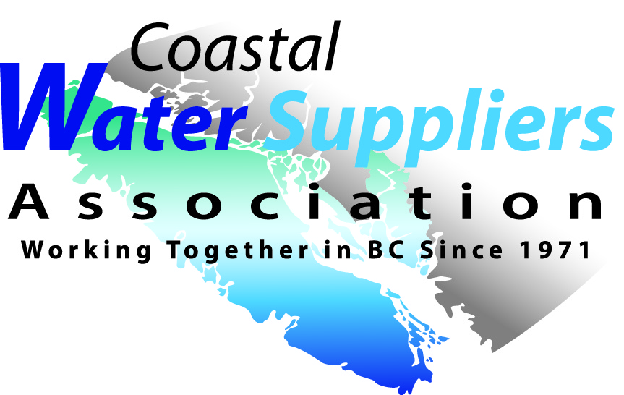
Coastal Water Suppliers Association
Minutes of May 9, 2017
Regular Board Meeting

Attendance: Ron Stepaniuk, Donna Monteith, Leon Cake, Joe Woolls
Regrets: Vernon Rogers, Michelle Price

Call to order 10:48am by R. Stepaniuk.
1. Approval of Agenda
Motion by R. Stepaniuk to adopt the May 9, 2017 meeting Agenda. 2nd by J. Woolls. Carried
2. Election of Chair
Motion by L. Cake to elect R. Stepaniuk as Chairperson for the 2017-2018 year. 2nd J. Woolls.
R. Stepaniuk accepts.
3. Minutes of Feb 27, 2017 Meeting
Motion by L. Cake to adopt the Feb 27, 2017 meeting minutes as presented. 2nd by J. Woolls. Carried
4. Business Arising
a) 2017 Annual Conference
24 Operators were registered in each course, 47 in Admin plus the speakers and the Board, and all trade tables were full. Over $9,000 collected online. Full financials will be available at the next meeting. Discussion regarding the feedback survey and general ideas about next year's conference occurred. If we hold it in Nanaimo again an idea might be to rent the whole ballroom. The flow would be to have Operators and Admin at each end with the Trades in the centre. During lunch the doors would open to allow all of us to visit and walk through the trade show. This way the Operators are not on a separate floor. Other suggestions were, but not limited to:
- have an ice breaker during the introductions
- have all trades introduce themselves
- networking sessions
- "Ask an Expert" session
- speaker on surface water
- end earlier in Admin and watch ferry schedules
- take photos for website
- order proper name tags for Administrator and Board
- Operator of the Year Award
- invite Mike Ippen to speak
- develop approved EOCP courses
- meet and greet in pub the night before the conference

A lot of the comments regarding ice breakers and networking had to do with new Trustees and Administrators coming to our conference but not knowing anyone there. They would like to get a better idea of who is in attendance and help build their network.

b) CWSA Business Plan - tabled until after AGM
5. New Business
BCWWA Conference Table - BCWWA has offered a free tabletop display at their conference May 28-29, 2017 in Victoria. Ron and Joe will do it on Sunday and Vernon on Monday.
The new CAO of North Cedar ID, Michael Bolch, has contacted Donna. He is happy to provide their facility for some Board Meetings and training.
Fall Workshop - Initial discussions. VIHA is looking for avenues to get their word out so perhaps we can work something out with them. More ideas and discussion to follow at the next meeting.
6. Next Meeting
TBA
7. Adjournment
Motion by J. Woolls to adjourn 12:52pm, 2nd by L. Cake Carried

