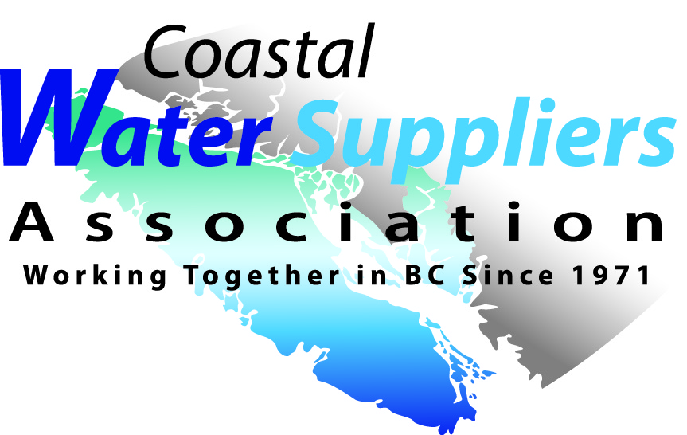
Coastal Water Suppliers Association
Minutes of June 16, 2018
Regular Board Meeting

Attendance: Ron Stepaniuk, Donna Monteith, Michael Bolch, Joe Woolls, Leon Cake, Vern Rogers

1. Call to order - 10:46am by R. Stepaniuk, Chair
2. Approval of Agenda
Motion by J. Woolls to adopt the June 16, 2018 meeting Agenda. 2nd by M. Bolch. Carried
3. Minutes of June 16, 2018 Meeting
Motion by M. Bolch to adopt the June 16, 2018 meeting minutes as presented. 2nd by J. Woolls. Carried

4. Business Arising
A response was received from ADA Faganello, MAH regarding direct access to funding. It was similar to the letter Deep Bay ID received in March. The letter should be circulated to our members and WSABC.

5. Financial Statements
Administrator D. Monteith presented the Financial Statements to May 31, 2018.

Motion by J. Woolls to adopt the Financial Statements to May 31, 2018 as distributed. 2nd by L. Cake.
Carried
6. New Business
Fall Workshop - The idea of Asset Management was discussed. The why's and how's. SIS and Econics could perhaps speak. There are a few conferences this fall so we need to ensure no overlap. On a side note we should have a direct link to the free asset management worksheets developed by SIS on our website.
7. Next Meeting Date
TBA
8. Adjournment
Motion by J. Woolls to adjourn 12;01pm, 2nd by M. Bolch Carried

